Final Exam

Jeremiah Barnes

CS 371

Apex Stats

So, Initially I went a little overboard and went ahead and made the full wamp-server website. I used the .css style sheet as well as other parts from the old project to make the website, however the database was completely original.

I know legend info only has two fields, I was hoping because there are seven others with 3+ that was okay. Functionally I didn’t know what else to add to it, but I also didn’t know how to get rid of it or add it somewhere else as it was important

Legend info:

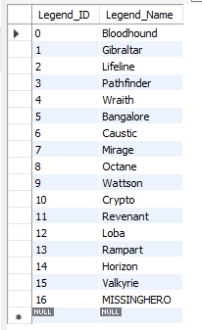

Gun Info:

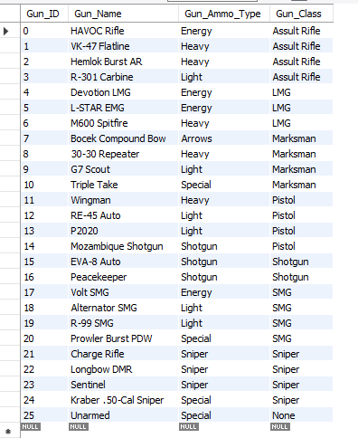

Map Info:

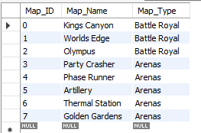

Location Info:

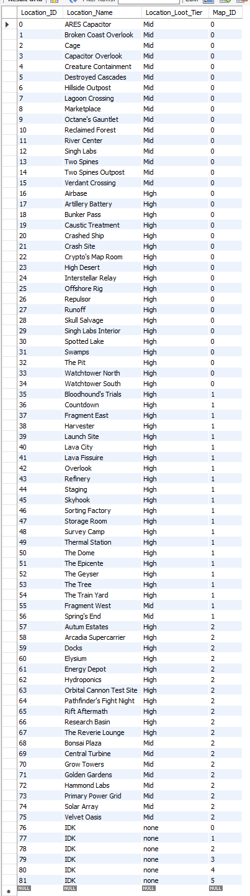

Duos:

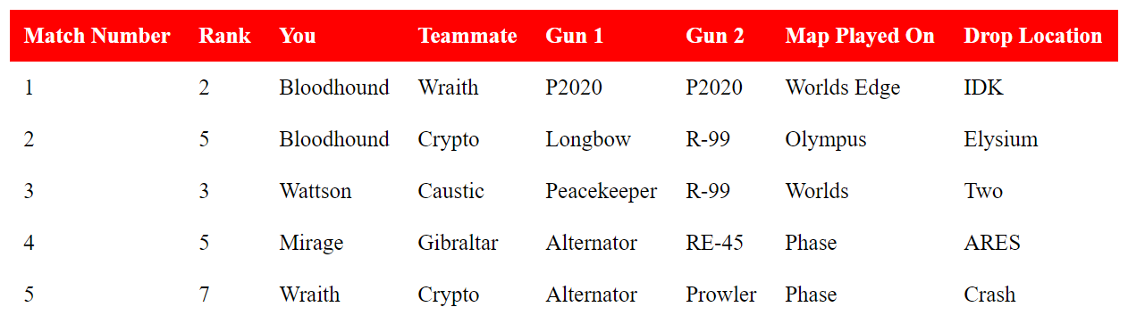

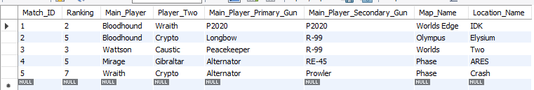

Trios:

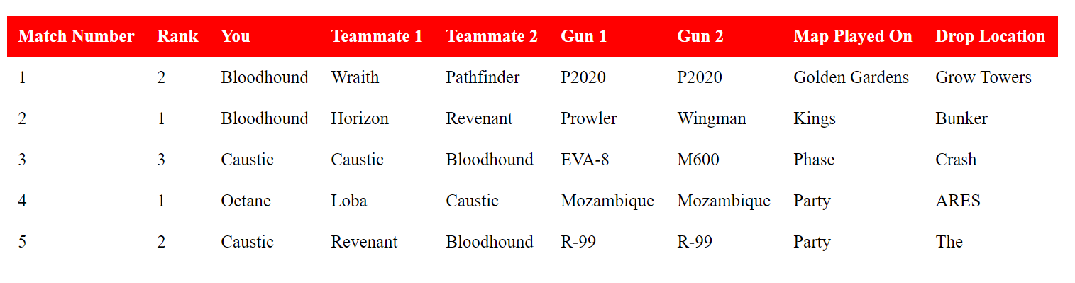

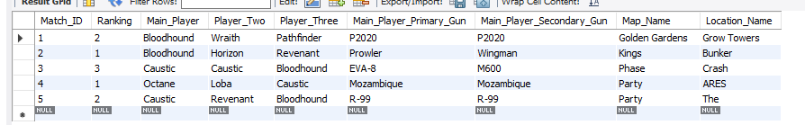

Ranked:

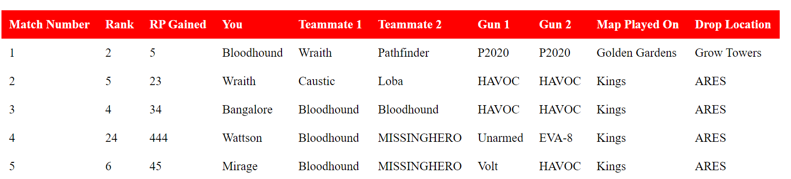

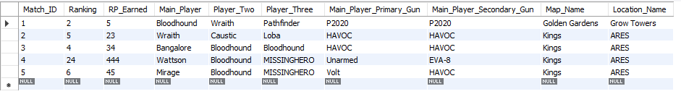

Arena:

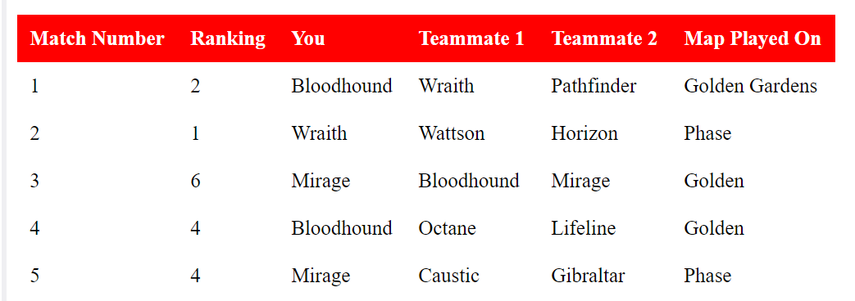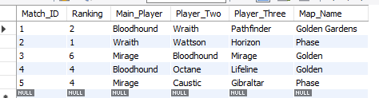

Where I would continue; I would want to create a lot of rules about how two people cant pick the same hero, you have to pick a location based on the map. As well as on the home page start to average some stats for each section. I think it’s a good framework though.